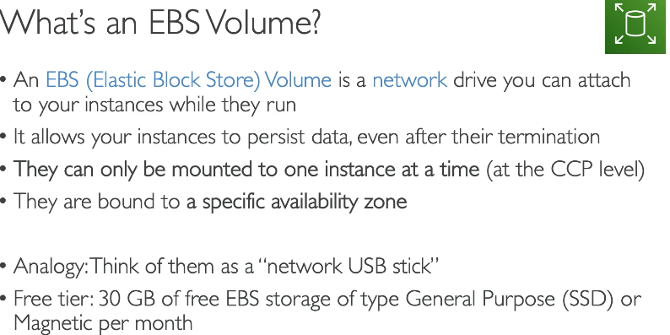

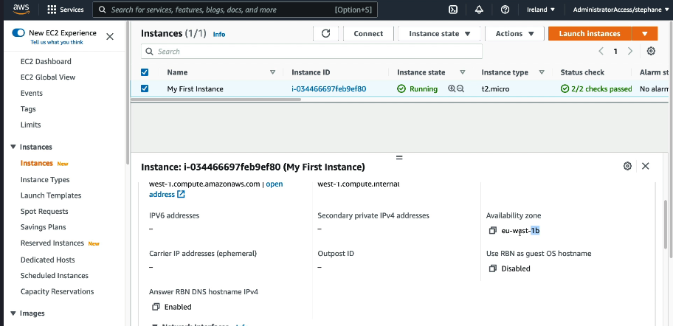

What is EC2 Instance Store?
Amazon EC2 Instance Store provides temporary (ephemeral) storage that is directly attached to the EC2 instance. It offers high-speed, low-latency storage, but data is lost when the instance stops or is terminated.
📌 Key Characteristics:
✅ Fast & Low Latency – Directly attached storage for high-speed operations
✅ Temporary Storage – Data is lost if the instance stops/terminates
✅ Not Persistent – Unlike EBS, it does not survive reboots
✅ High IOPS – Best for cache, temporary files, or batch processing

How EC2 Instance Store Works?
📌 Instance Store is physically attached to the EC2 host machine and provides block-level storage that is only accessible by that instance.
🔹 Data is lost when:
✔️ The EC2 instance is stopped
✔️ The EC2 instance is terminated
✔️ The underlying hardware fails
💡 Data persists only when the instance is running!

Use Cases for Instance Store
✅ Temporary Data Storage – Session-based storage, caches, temp files
✅ High-Speed Processing – Big data, machine learning, real-time analytics
✅ Swap/Buffer Space – Temporary disk for high-performance applications
✅ Media Transcoding – Storing temporary video files during processing
📌 For your Chat App (Django + MySQL + Nginx)
❌ Not recommended for MySQL data storage (Data loss risk)
✅ Good for caching session data or log files

EC2 Instance Store vs EBS
Feature | EC2 Instance Store | Amazon EBS
Persistence | ❌ Lost on stop/terminate | ✅ Persistent
Performance | ⚡ Very high-speed | ⚡ High-performance but slower than Instance Store
Attach/Detach | ❌ Cannot be detached | ✅ Can be detached & reattached to another instance
Snapshots | ❌ No backups or snapshots | ✅ Snapshots available
Best Use Case | Temporary storage (cache, logs, buffers) | Long-term storage (databases, files, backups)

Types of EBS Volumes
Amazon EBS offers different volume types based on performance and cost:
Volume Type |  | Use Case |  |  |  |  |  |  | Performance
gp3 (General Purpose SSD) |  | Default for most workloads |  |  |  |  |  |  | Up to 16,000 IOPS
gp2 (Older General Purpose SSD) |  | Balanced cost & performance |  |  |  |  |  |  | 3 IOPS per GB
io2 / io1 (Provisioned IOPS SSD) |  | High-performance databases |  |  |  |  |  |  | Up to 256,000 IOPS
st1 (Throughput Optimized HDD) |  | Big data, log processing |  |  |  |  |  |  | 500 MB/s
sc1 (Cold HDD) |  | Archiving & infrequent access |  |  |  |  |  |  | 250 MB/s
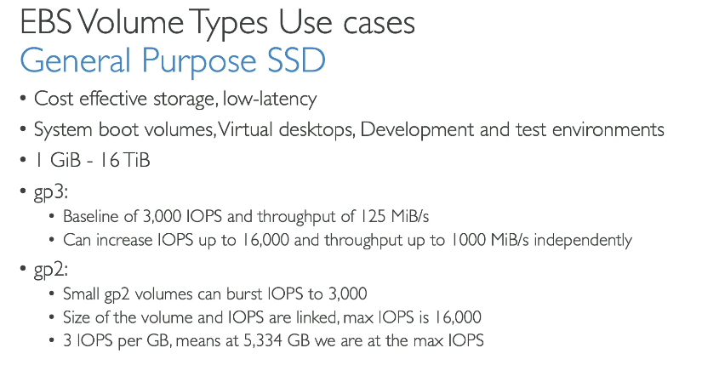
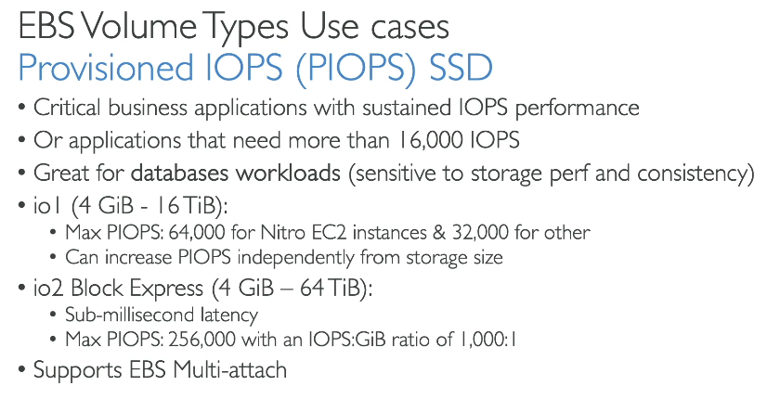
Amazon EBS Multi-Attach 🚀
1 What is EBS Multi-Attach?
EBS Multi-Attach allows a single Amazon EBS volume to be attached to multiple EC2 instances simultaneously within the same Availability Zone (AZ).
📌 Key Features:
✅ Shared storage across multiple EC2 instances
✅ Supports only io1/io2 volumes (Provisioned IOPS SSD)
✅ Up to 16 EC2 instances can attach to the same EBS volume
✅ Read and Write operations from multiple instances
✅ Best for clustered applications like databases, distributed computing, and shared logs

2️How EBS Multi-Attach Works?
- Unlike standard EBS volumes (which can only attach to one EC2 instance at a time), Multi-Attach allows multiple EC2 instances to simultaneously access the same volume.
- Applications must be cluster-aware to handle concurrent writes and avoid data corruption.
- File systems like XFS, Lustre, and shared databases work best with Multi-Attach.

3️Use Cases for EBS Multi-Attach
✅ High-availability applications – Multiple instances accessing the same data
✅ Shared storage for containerized apps (Kubernetes, Docker Swarm)
✅ Distributed databases (e.g., MySQL Cluster, Cassandra)
✅ Parallel computing – Sharing large datasets across instances
✅ Shared logs and metadata
📌 For your Chat App (Django + MySQL + Nginx)
- Not recommended for MySQL databases ❌ (risk of corruption)
- Can be useful for shared logs or static content storage ✅

4️Setting Up EBS Multi-Attach
Step 1: Create an io1/io2 EBS Volume with Multi-Attach Enabled
- Go to AWS Console → EC2 → Volumes
- Click Create Volume
- Choose io1/io2 (Provisioned IOPS SSD)
- Check Enable Multi-Attach
- Attach the volume to multiple EC2 instances in the same AZ
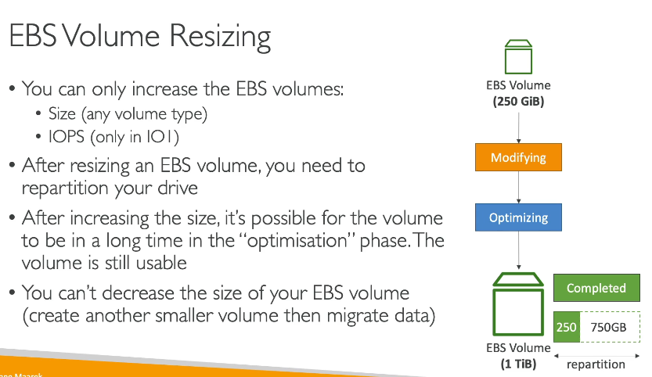
Amazon EBS Volume Resizing allows you to increase the size, change the volume type, or modify the IOPS of an existing EBS volume without downtime.
📌 Key Features:
✅ Increase storage size without data loss
✅ Modify volume type (e.g., gp2 → gp3 or io1 → io2)
✅ Increase IOPS for better performance
✅ Live modifications without stopping the instance
✅ Resizing takes a few minutes, but filesystem expansion is require
Step 1: Modify the EBS Volume (AWS Console)
- Go to AWS Console → EC2 → Volumes
- Select the EBS Volume you want to resize
- Click Modify Volume
- Increase the Size (GB) or change the Volume Type
- Click Modify and confirm.

Resize the Filesystem on the EC2 Instance
Even after resizing the volume, the filesystem must be expanded to use the extra space.
Lsblk
sudo growpart /dev/xvda 1
sudo resize2fs /dev/xvda1
sudo xfs_growfs /

Method | Use Case

growpart + resize2fs / xfs_growfs | Extend existing partition (no need for new mount points)

fdisk + mkfs + mount |  | Create a separate partition for logs, databases, etc.

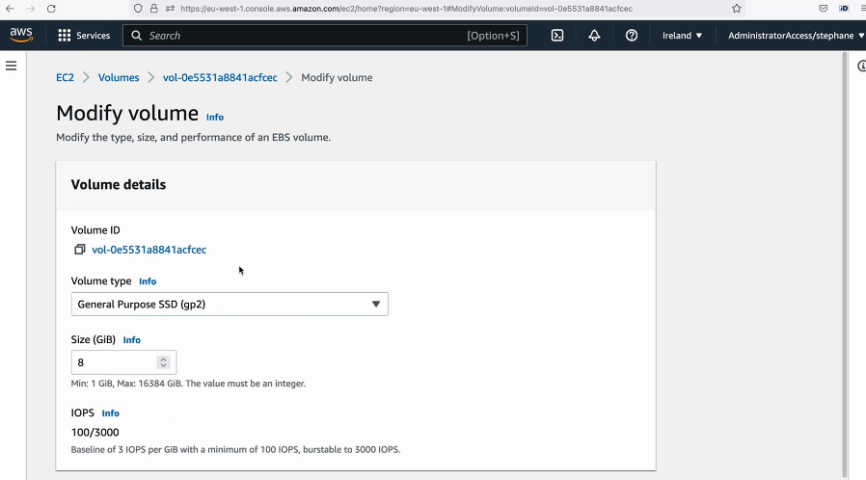

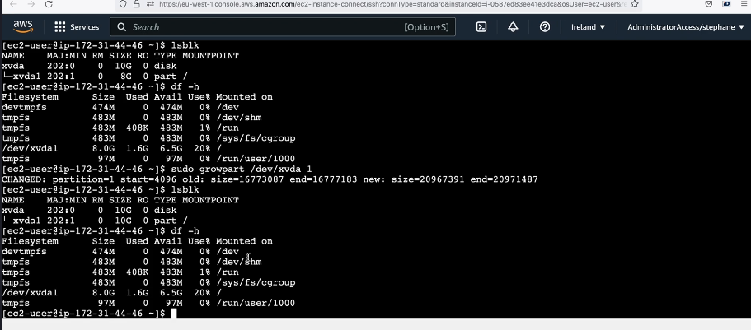

EBS Snapshots: Overview & Operations
EBS Snapshots are point-in-time backups of your Elastic Block Store (EBS) volumes. They are stored in Amazon S3 (but not visible in S3) and can be used to restore data or create new volumes.

🔹 Why Use EBS Snapshots?
✔️ Backup: Create backups of your EBS volumes for disaster recovery.
✔️ Restore: Recover lost data by creating a new volume from a snapshot.
✔️ Migration: Move data between AWS regions.
✔️ Scaling: Create multiple copies of a volume for different instances.
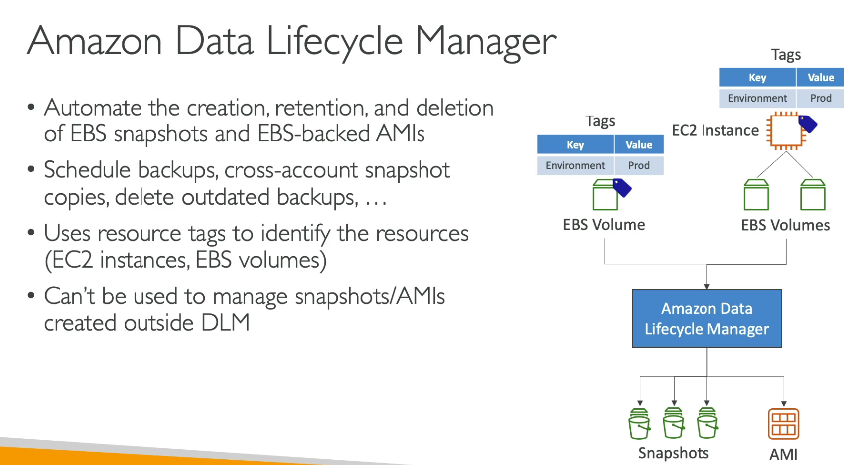

Fast Snapshot Restore (FSR) allows you to restore an EBS volume from a snapshot instantly, without waiting for data to be loaded from Amazon S3.
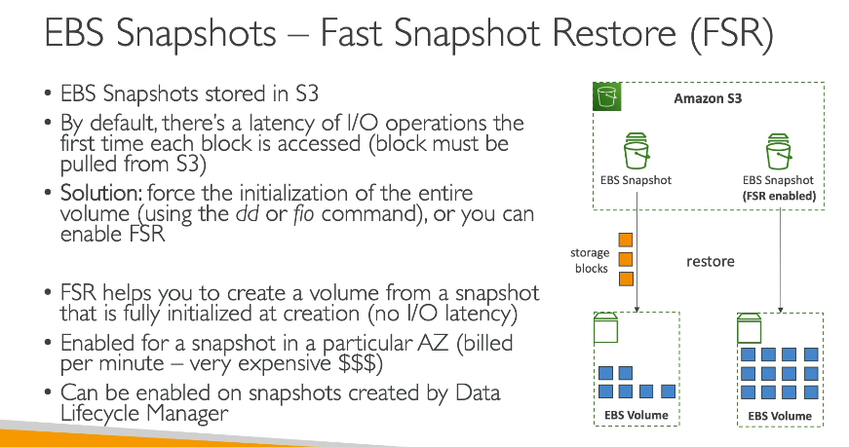
EBS Snapshot Archive Tier
The EBS Snapshot Archive Tier is a cost-effective storage option for long-term retention of Amazon EBS snapshots. It reduces costs by up to 75% compared to standard snapshots.

🔹 Why Use the Archive Tier?
✅ Lower Cost: Saves money on rarely accessed snapshots.
✅ Ideal for Compliance & Backup: Useful for regulatory backups.
✅ Supports Long-Term Storage: Store snapshots for months/years.
✅ Easily Restore When Needed: Move snapshots back to the standard tier when required.

AWS Console Method
- Open EC2 Dashboard → Go to Volumes
- Select the EBS Volume → Click on Actions
- Choose Create Snapshot
- Provide a name & description → Click Create Snapshot
- The snapshot will be available in the Snapshots section
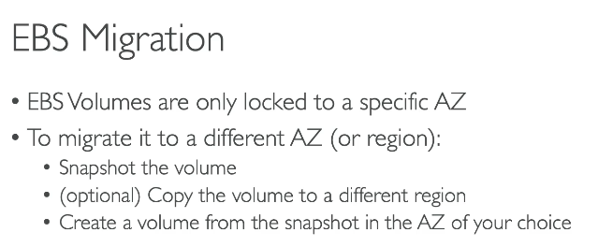
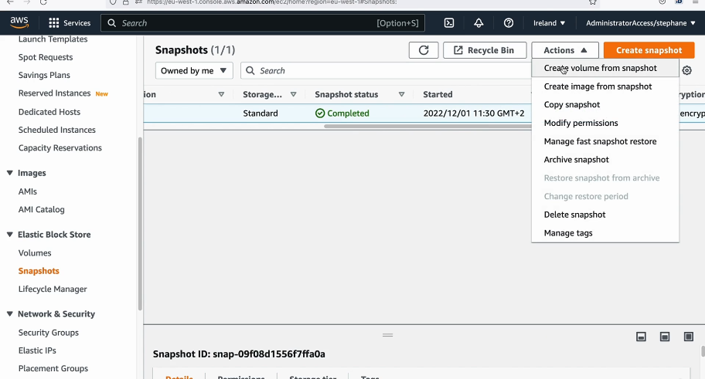

Amazon EFS (Elastic File System) Overview
Amazon EFS (Elastic File System) is a fully managed, scalable, and highly available file storage service for EC2 instances and other AWS services. It provides shared file storage that can be accessed by multiple instances simultaneously.

🔹 Why Use Amazon EFS?
✅ Fully Managed: AWS handles scaling, backups, and availability.
✅ Highly Scalable: Automatically grows/shrinks as files are added/removed.
✅ Multi-AZ Availability: Data is stored across multiple Availability Zones (AZs).
✅ Multi-Instance Access: Multiple EC2 instances can mount the same EFS.
✅ Supports NFS (Network File System v4.1/4.0).
✅ No Pre-Provisioning: You don’t need to allocate a fixed size; it scales automatically.
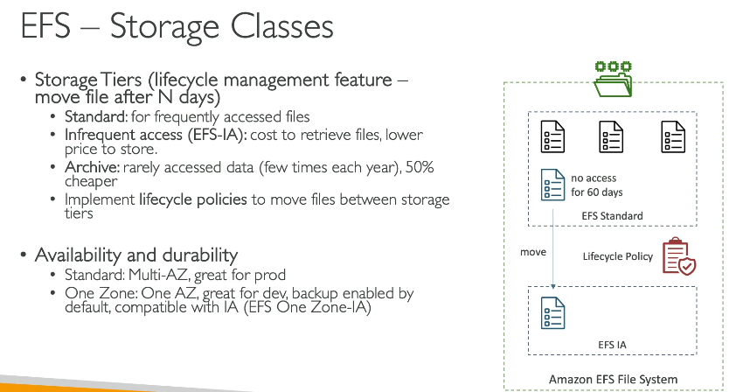

Create an EFS File System (AWS Console)
1 Open the AWS Console and Go to EFS
- Open the AWS Management Console.
- Navigate to Amazon EFS.
- Select your EFS file system.

📌 2 Create a Mount Target
- Go to the Network tab.
- Click "Create mount target".
- Select the VPC where your EC2 instance is running.
- Choose Subnets in the Availability Zone (us-east-1a) where your EC2 instance is located.
- Assign a Security Group that allows NFS (port 2049) inbound traffic.
  - You can create a new Security Group with this rule:
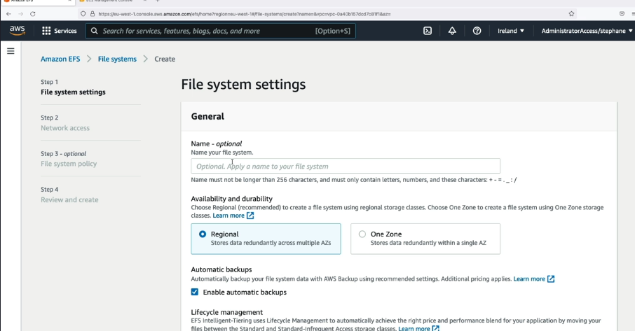

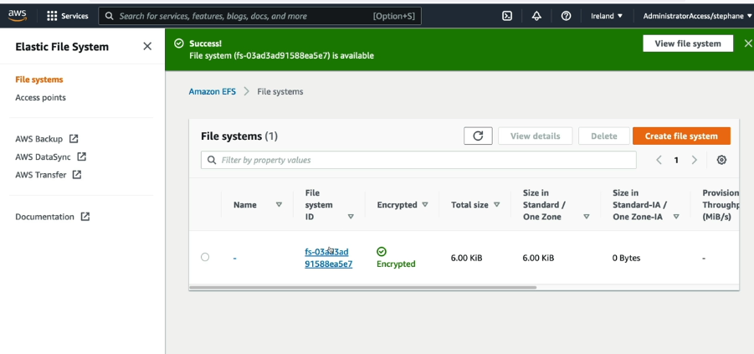

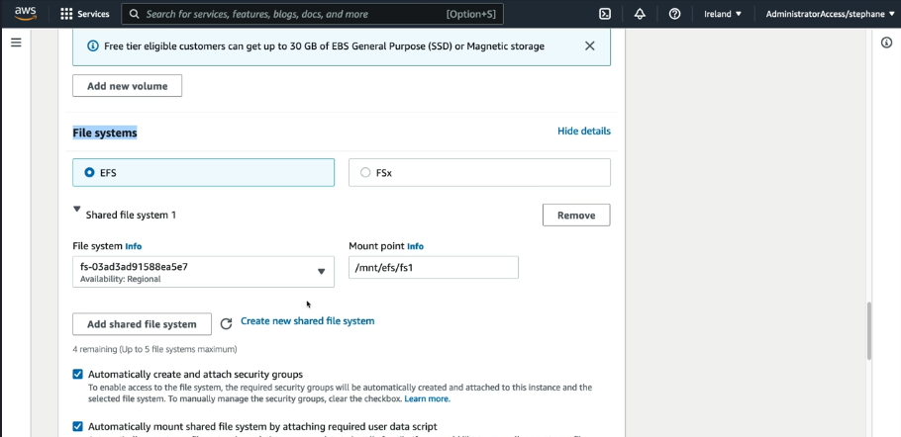
Amazon EFS vs. EBS vs. S3
Feature | Amazon EFS |  |  |  |  | Amazon EBS |  |  |  |  | Amazon S3
Type | File System |  |  |  |  | Block Storage |  |  |  |  | Object Storage
Use Case | Shared file storage for multiple EC2s |  |  |  |  | High-performance disk for a single EC2 |  |  |  |  | Store and retrieve objects (images, logs, backups)
Access | Multiple instances (NFS) |  |  |  |  | Single instance (unless using Multi-Attach) |  |  |  |  | Public or private access via API
Scalability | Auto-scales with data growth |  |  |  |  | Needs manual resizing |  |  |  |  | Unlimited storage
Performance | Good for shared workloads |  |  |  |  | Low latency, high IOPS |  |  |  |  | Optimized for object retrieval
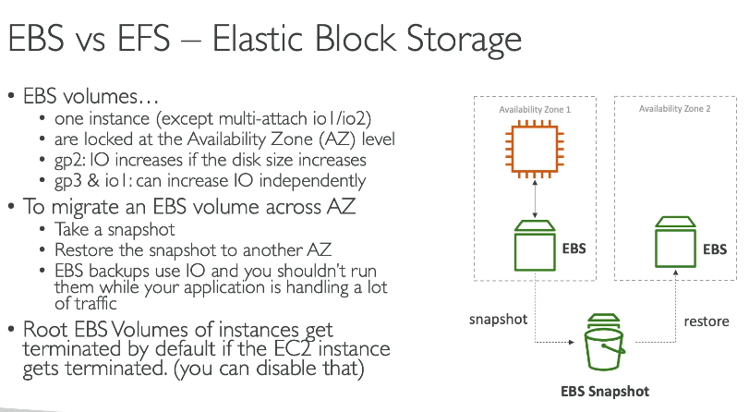

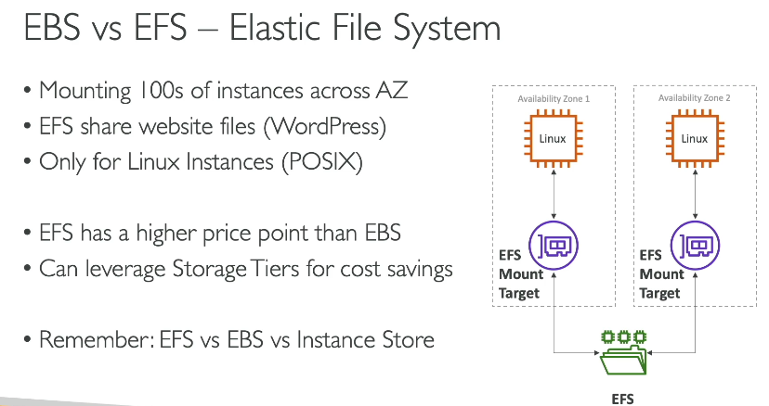
Amazon EFS Access Points
An EFS Access Point is a feature that allows you to create a controlled entry point into your EFS file system. It helps in managing permissions and restricting access to specific directories within the file system.

🔹 Why Use EFS Access Points?
✅ Provides fine-grained permissions for different users/applications.
✅ Helps enforce user identity (UID/GID) for security.
✅ Supports multi-tenant applications by restricting access to specific directories.
✅ Useful for containers (ECS, EKS, Lambda) that need isolated access to EFS.

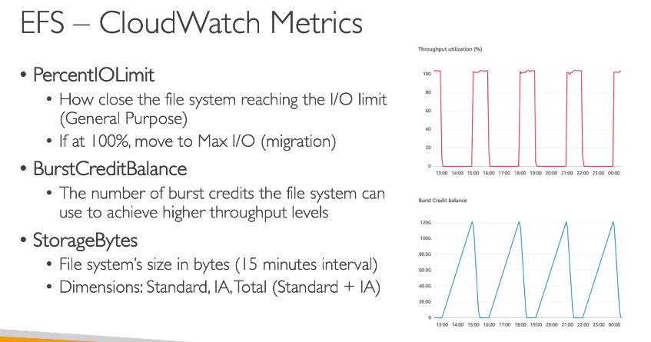

What is "Bursting" in AWS?
Bursting refers to the ability of a resource (such as EBS, EFS, or EC2) to temporarily exceed its baseline performance when needed. AWS provides burst credits to allow short-term spikes in performance beyond the usual limits.

🔹 Types of Bursting in AWS
1️EBS (Elastic Block Store) Bursting
- General Purpose (gp2/gp3) EBS volumes use I/O credits to burst higher than their baseline IOPS (Input/Output Operations per Second).
- If you run out of credits, performance drops to the baseline level.
- Example: A 100 GiB gp2 volume has a baseline of 300 IOPS but can burst up to 3000 IOPS when needed.

2️EFS (Elastic File System) Bursting
- EFS Standard Storage Class supports burstable throughput.
- It provides Burst Credits, which accumulate when you use less than the baseline and are consumed when you need higher throughput.
- Example: If your EFS has a baseline of 50 MiB/s, it can burst up to 100 MiB/s for a limited time.

3️EC2 CPU Credit Bursting (T-Series Instances)
- T2, T3, and T4g instances use CPU credits to burst beyond their allocated vCPU.
- Example: A t2.micro instance has a baseline CPU of 10%, but it can burst to 100% CPU usage if it has CPU credits.

🔹 Example for Your Chat App
If your chat application suddenly gets high traffic, and your EFS is configured in the bursting mode: ✅ It will automatically increase throughput to handle the spike.
✅ If you have enough burst credits, your users won't see delays.
✅ Once credits are used up, performance will return to the baseline.

EFS Lifecycle Management Overview
Amazon Elastic File System (EFS) Lifecycle Management helps automatically move files between storage classes to reduce costs based on access patterns. It transitions files from Standard Storage to Infrequent Access (IA) Storage when they haven’t been accessed for a defined period.

✅ Why Use EFS Lifecycle Management?
- Cost Savings – Moves less frequently accessed files to a lower-cost storage class.
- Automated Storage Tiering – No manual intervention needed.
- Performance Optimization – Keeps frequently accessed files in Standard Storage.

How to Encrypt an Unencrypted Amazon EFS File System?
Amazon EFS does not allow enabling encryption on an existing unencrypted file system. However, you can migrate your data to a new encrypted EFS and use it instead.

✅ Steps to Encrypt an Existing Unencrypted EFS File System
Since EFS encryption cannot be enabled on an existing EFS, follow these steps:
Step 1: Create a New Encrypted EFS File System
1️Go to the AWS Management Console → EFS
2️Click Create File System
3️Enable Encryption at Rest (This will use AWS KMS for encryption)
4️Choose a KMS key (default or custom)
5️Click Create
Step 2: Mount Both EFS File Systems
Mount both the old (unencrypted) EFS and the new (encrypted) EFS on your EC2 instance.
Step 3: Copy Data to the Encrypted EFS
Step 4: Update the Application to Use the Encrypted EFS

How to Encrypt an Unencrypted EBS Volume?
Amazon EBS does NOT support direct encryption of an existing unencrypted volume. However, you can encrypt it by creating a snapshot and restoring it as an encrypted volume.

✅ Step-by-Step Guide to Encrypt an Unencrypted EBS Volume
Since EBS does not allow in-place encryption, follow these steps:
Step 1: Create a Snapshot of the Unencrypted EBS Volume
Step 2: Copy the Snapshot & Enable Encryption
Step 3: Create a New Encrypted EBS Volume from the Snapshot

Step 4: Attach the New Encrypted Volume to Your EC2 Instance
Step 5: Mount the New Volume & Copy Data

